University of Petroleum and Energy Studies



# Internship - Low Level Design

**on**

**Cloud-Based Bus Pass System**

Team members:

|  |  |
| --- | --- |
| Gaurav Porwal | R110219054 |
| Kumar Baibhav | R110219074 |
| Anirudh Kushwah | R110219015 |
| Nayan Naugain | R110219090 |
| Kushagra Joshi | R110219161 |

Guided by: Vijendra Singh

Industry Mentor: Yogesh Ghorpade

# Table of Contents

1. Introduction 3
   1. Scope of the document 3
   2. Intended audience 3
   3. System overview 3
2. Low Level System Design. 4
   1. Sequence Diagram 5
   2. Navigation Flow/UI Implementation. 6
   3. Screen Validations, Defaults and Attributes. 7
   4. Client-Side Validation Implementation. 7
   5. Server-Side Validation Implementation. 7
   6. Components Design Implementation. 8
   7. Configurations/Settings. 8
   8. Interfaces to other components 8
3. Data Design. 9
   1. List of Key Schemas/Tables in database 9
   2. Details of access levels on key tables in scope 9
   3. Key design considerations in data design. 9
4. Details of other frameworks being used. 10
   1. Session Management 10
   2. Caching. 10
5. Unit Testing. 11
6. Key notes. 12
7. Reference 12

## Introduction

A cloud-based bus pass system is useful to the people as it is easily available through the internet in contrast to the traditional bus pass system where the authority issued the pass to the user which is rather time-consuming and inconvenient. The user had to wait in long queues to get their passes. Therefore, a cloud-based system will overcome these limitations of the current public transport system. The project aims to provide a more convenient, reliable and efficient way to bus pass generation. As the complete system is online, hence it is faster than the previously used manual system.

### Scope of the document

In the traditional system, pass generation and renewal was a manual process. The user had to visit the office and submit their details and wait for approval which is a time-consuming way. cloud-based bus pass system is a digital approach where we can remove the limitations of the traditional system. With a digital pass the hassle of getting a physical pass is eliminated. This model provides the flexibility of issuing bus pass online. The main objective of this system is to automate pass issuing procedure and enable safe and secure payments as well through the use of UPIs.

### Intended audience

The system can be used by any bus transport service. This model can be used by government or in the private sector to automate bus pass generation and save time and money. The intended user of this system is the general public. People working 9-5 jobs and students going to colleges or schools can now simply issue their passes online and save time by not waiting in long queues to get their pass. This is an efficient approach for the daily passenger in their day-to-day bus journey.

### System Overview

The system for the smooth working of this LMS Portal require the following hardware and software components:

**1. Hardware Components:**

1.1 Primary Memory (RAM) - 4GB and higher

1.2 Secondary memory (ROM) - 5-GB and higher

1.3 Processor - Intel CORE i3 and higher

**2. Software Components:**

2.1 OS : Windows 10

2.2 Cloud : AWS, AZURE

2.3 Front end : Html, CSS, Java Script, Bootstrap

2.4 Back end : Cloud shell, Node JS, Express.JS, React.JS

2.5 Database : MongoDB

## Low Level System Design

The Low Level System Design (LLD) is a component level design process that follows a step by-step refinement process. LLD is also called the detailed or micro-level design of a system. It describes every module in detail by incorporating the logic behind every component in the system and also focuses more on designing all components in detail.

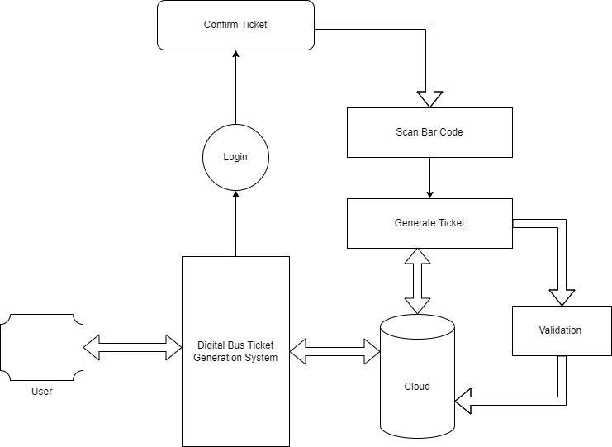

### Sequence Diagram

* Sequence diagram for user login

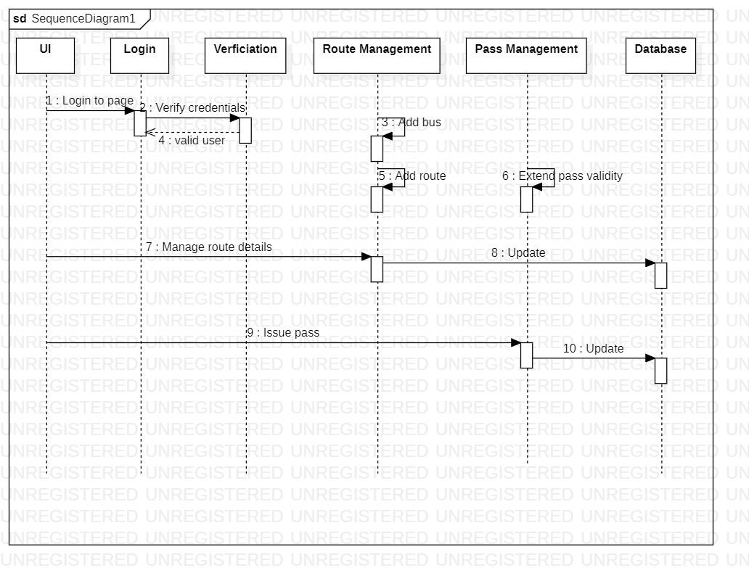

### Navigation Flow/UI Implementation

### 

**Screen Validations, Defaults and Attributes**

The users can access the pass system with their email or mobile number and along with the correct password for the validation process.

### Client-side Validation Implementation

Client-side validation is an initial check and an important feature of good user experience; by catching invalid data on the client-side, the user can fix it straight away.

**Server-side Validation Implementation**

As soon as the user makes an attempt to login, his credentials are matched with the details stored in database at the server side and only the valid user are allowed to gain access.

### Components Design Implementation

The process can be considered as People–Process–Product continuum or P3 models. The P3 model is a holistic approach to course development and helps in not only creating very high quality e learning content but also in the submission and maintenance of the course.

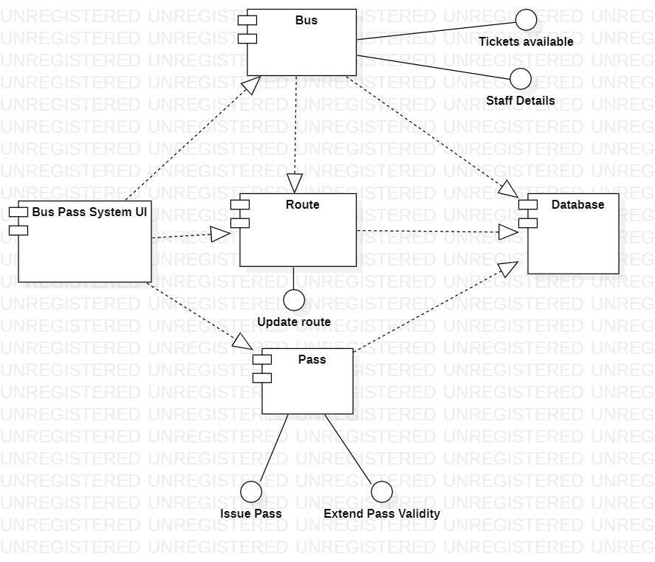

### Configurations/Settings

There is a defined Settings menu under the configuration tab in the eLearning module where the various options for the eLearning operations can be enabled, dialed, and configured.

Options such as Assignment, Feedback, Book, Glossary, Course, Description, Forum, Quiz, etc.

### Interfaces to other components

The term User Interface (UI) refers to the visual part of an app or an e-learning course that users interact with. This includes any menus, navigation buttons, and page (or slide) layouts. A good UI is one that users intuitively understand how to interact with. User interface (UI) is point of interaction between user and computer software. The success and failure of a software application depends on User Interface Design (UID). Possibility of using a software, easily using and learning are issues influenced by UID. The UI is significant in designing of educational software (e learning) with characteristics:

• All contents should be related to the educational aim

• Curriculum must be designed according to the characteristics and tools of e-learning. • The factors affecting education must be considered

• Combining individual and corporation learning and group teaching must benefit from appropriate method

• Using multimedia such as: voice, picture, text, etc. have a crucial role in presentation of the lessons.

## Data Design

We are using MongoDB Database to store the data, where we have a table that stores the email id or mobile number of the user along with their passwords. The server validates the user by searching the email id or mobile number of users in the database and then matches the password with the password entered by the user. In this the email id or mobile number acts as the primary key for the schema

### List of schemas in database

The term schema refers to the organization of data as a blueprint of how the database is constructed.

* + - The student login credentials table
    - The admin/instructor login credentials table

### Key design considerations in data design

The various keys set to connect the different relations in this constellation schema of the relational database management system are-

## Details of other Frameworks being used

**1. Session Management**

Session management refers to the process of securely handling multiple requests to a web based application or service from a single user or entity. It is used to facilitate secure interactions between a user and the service or application and applies to a sequence of requests and responses associated with that particular user.

response.

• User Authentication

• HTML Hidden Field

• Cookies

• URL Rewriting

1. **Caching**

Caching is storing data in a location different than the main data source such that it's faster

to access the data. It is done to avoid redoing the same complex computation again and again. Caching in the Bus-Pass portal.

There are four types of caching in web paging-

• Site Caching

• Browser Caching

• Server Caching

• Micro Caching

**Unit Testing**

Unit testing is the lowest-level testing among the different testing types. Here, testers test individual components of a software or application. There are one or more inputs with a single output in most cases. Unit testing ensures that individual code sets work according to expectations before building a massive feature. It includes calculations and input validations.

1. **Front-end unit testing:**.Front-end testing validates that what people see on the site and the features they use on it work as intended.We are using HTML/CSS with React for the manufacture of Bus - Pass Site. The testing for this phase is for the proper functioning of the links, the user eye catchy designs and for providing proper guidance to the user.

2. **The database unit testing:** The database unit testing is done for seeing the smooth functioning of the data connection, the secure storage and for the accurate retrievals from the database. Database is getting maintained in MongoDB database management system and the connection is done through connector.

## References

[1] S. Kim, “Security Augmenting Scheme for Bus Information System based on Smart Phone”, International Journal of Security and Its Applications, vol. 7, no. 3,(2013), pp. 337-345.

(Accessed on 22 June 2022)

[2] J. Lee, K. Hong, H. Lee, J. Lim and S. Kim, “Bus information system based on smart-phone Apps”, in Proc.of KSCI Winter Conference (2012), pp. 219-222.

(Accessed on 25 June 2022)

[3] S. Chandurkar, S. Mugade, S. Sinha, M. Misal and P. Borekar, “Implementation of Real Time Bus Monitoring and Passenger Information System”, International Journal of Scientific and Research Publications, vol. 3, no. 5,(2013), pp. 1-5.